OPP Lab 1
Task 1
#include<iostream>
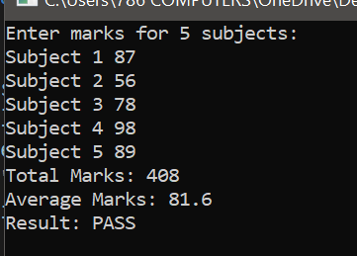
using namespace std;
int main()
{
int marks[]={87,56,78,98,89};
int Total=0;
float Average;
cout << "Enter marks for 5 subjects:"<<endl;
for(int i=0; i<5; i++)
{
cout<<"Subject "<<i+1<<" "<<marks[i]<<endl;
Total += marks[i];
}
cout <<"Total Marks: "<<Total<<endl;
Average = Total/5.0;
cout << "Average Marks: "<<Average<<endl;
if(Average < 50)
{
cout <<"Result: FAIL"<<endl;
}else
{
cout <<"Result: PASS"<<endl;
}
}
Task 2
#include<iostream>
using namespace std;
typedef struct Book{
int id;
string title;
string author;
float price;
}lib;
void input(lib b1[])
{
cout <<"Enter Details for 3 books: "<<endl;
for(int i=0; i<3; i++)
{
cin>>b1[i].id;
cin>>b1[i].title;
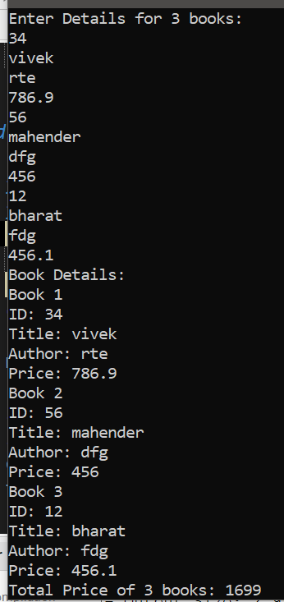
cin>>b1[i].author;
cin>>b1[i].price;
}
}
void display(lib b1[])
{
cout << "Book Details: "<<endl;
for(int i=0; i<3; i++)
{
cout << "Book "<<i+1<<endl;
cout<<"ID: "<<b1[i].id<<endl;
cout<<"Title: "<<b1[i].title<<endl;
cout<<"Author: "<<b1[i].author<<endl;
cout<<"Price: "<<b1[i].price<<endl;
}
}
void totalprice(lib b1[])
{
float total=0;
for(int i=0; i<3; i++)
{
total += b1[i].price;
}
cout <<"Total Price of 3 books: "<<total<<endl;
}
int main()
{
lib b1[3];
input(b1);
display(b1);
totalprice(b1);
}

Task 3
#include<iostream>
using namespace std;
struct Student{
int Roll;
string Name;
int marks[3];
float CGPA;
};
void input(struct Student *s[], int n)
{

for(int i=0; i<n; i++)
{
int total=0;
cout <<"Enter details for Student"<<i+1<<endl;
cout <<"Roll No: ";
cin>>s[i]->Roll;
cout <<"Name: ";
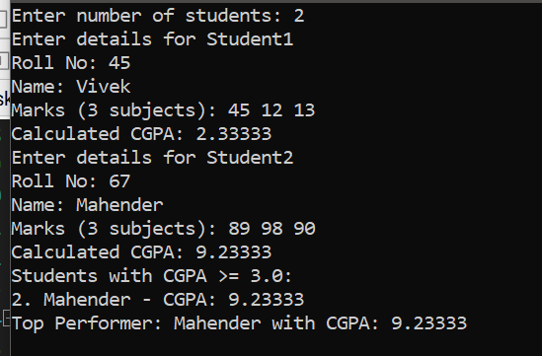
cin>>s[i]->Name;
cout <<"Marks (3 subjects): ";
for(int j=0; j<3; j++)
{
cin>>s[i]->marks[j];
total += s[i]->marks[j];
}
s[i]->CGPA = total/30.0;
cout <<"Calculated CGPA: ";
cout <<s[i]->CGPA<<endl;
}
}
void CGPA(struct Student *s[], int n)
{
cout <<"Students with CGPA >= 3.0:"<<endl;
for(int i=0; i<n; i++)
{
if(s[i]->CGPA >= 3.0)
{
cout <<i+1<<". "<<s[i]->Name<<" - CGPA: "<<s[i]->CGPA<<endl;
}
}
int highest=s[0]->CGPA;
int index =0;
for(int i=1; i<n; i++)
{
if(s[i]->CGPA > highest)
{
highest = s[i]->CGPA;
index = i;
}
}
cout <<"Top Performer: "<<s[index]->Name<<" with CGPA: "<<highest<<endl;
}
int main()
{
int n;
cout <<"Enter number of students: ";
cin>>n;
Student *s[n];
for(int i=0;i<n;i++)
s[i] = new Student;
input(s,n);
CGPA(s,n);
for(int i=0;i<n;i++)
delete s[i];
return 0;
}

